OWASP ZAP Security Assessment Report
Author
Prince Arora
BCA Cyber Security

1. Introduction
This document presents a practical security assessment of the OWASP Juice Shop application using OWASP ZAP. The testing environment was created locally with Docker, followed by automated scanning and analysis of detected issues. The report explains the complete workflow, observations, findings and suggested security improvements.

2. Docker Login and Pull
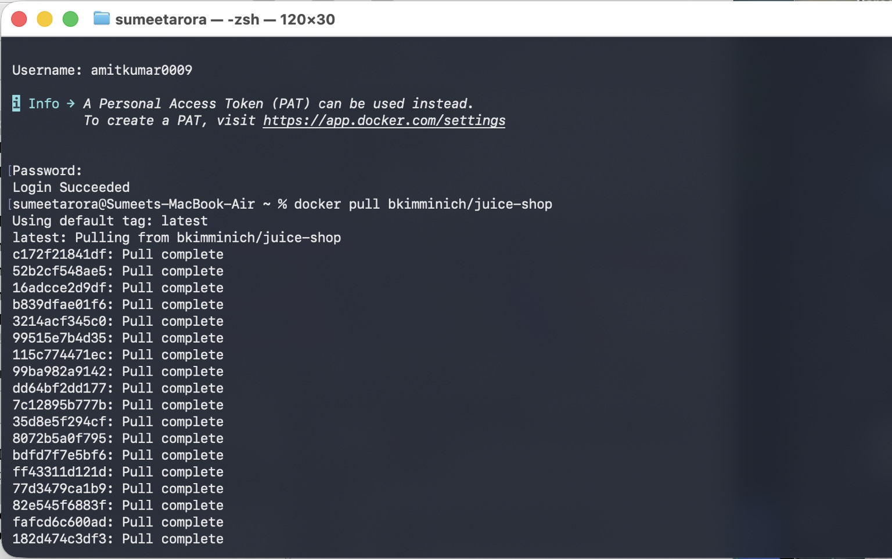
Summary
Docker authentication was completed before downloading the required image. The OWASP Juice Shop Docker image was downloaded using the command 'docker pull bkimminich/juice-shop'. This downloaded all required image layers and prepared the vulnerable web application for deployment.
Result: The screenshot verifies that this phase was completed successfully and the expected output was achieved.

3. Running Juice Shop Container
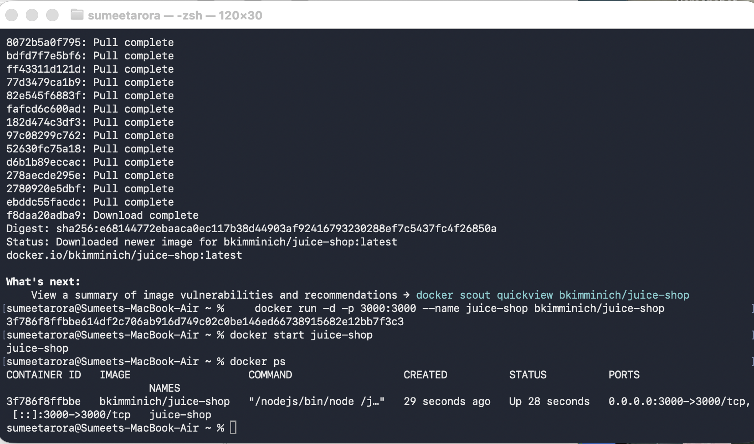
Summary
The Juice Shop container was launched using the docker run command and mapped to port 3000. The docker ps command confirmed that the container was running successfully.
Result: The screenshot verifies that this phase was completed successfully and the expected output was achieved.

4. OWASP Juice Shop Homepage
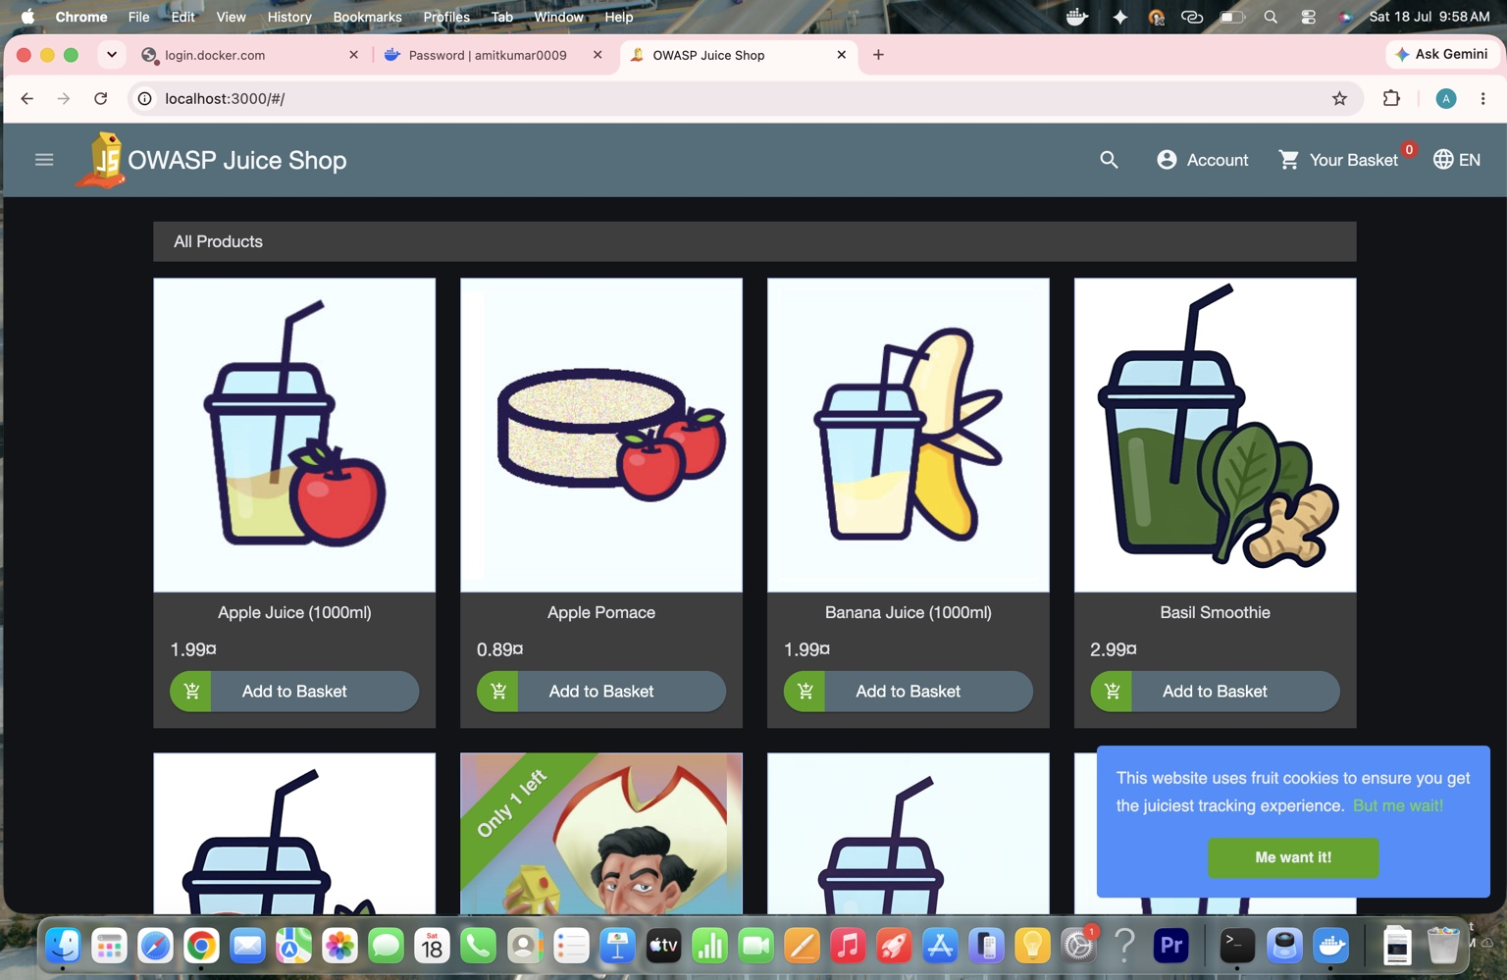
Summary
The web application loaded correctly in the browser at http://localhost:3000. This confirmed that the local web application was ready for penetration testing.
Result: The screenshot verifies that this phase was completed successfully and the expected output was achieved.

5. Launching OWASP ZAP
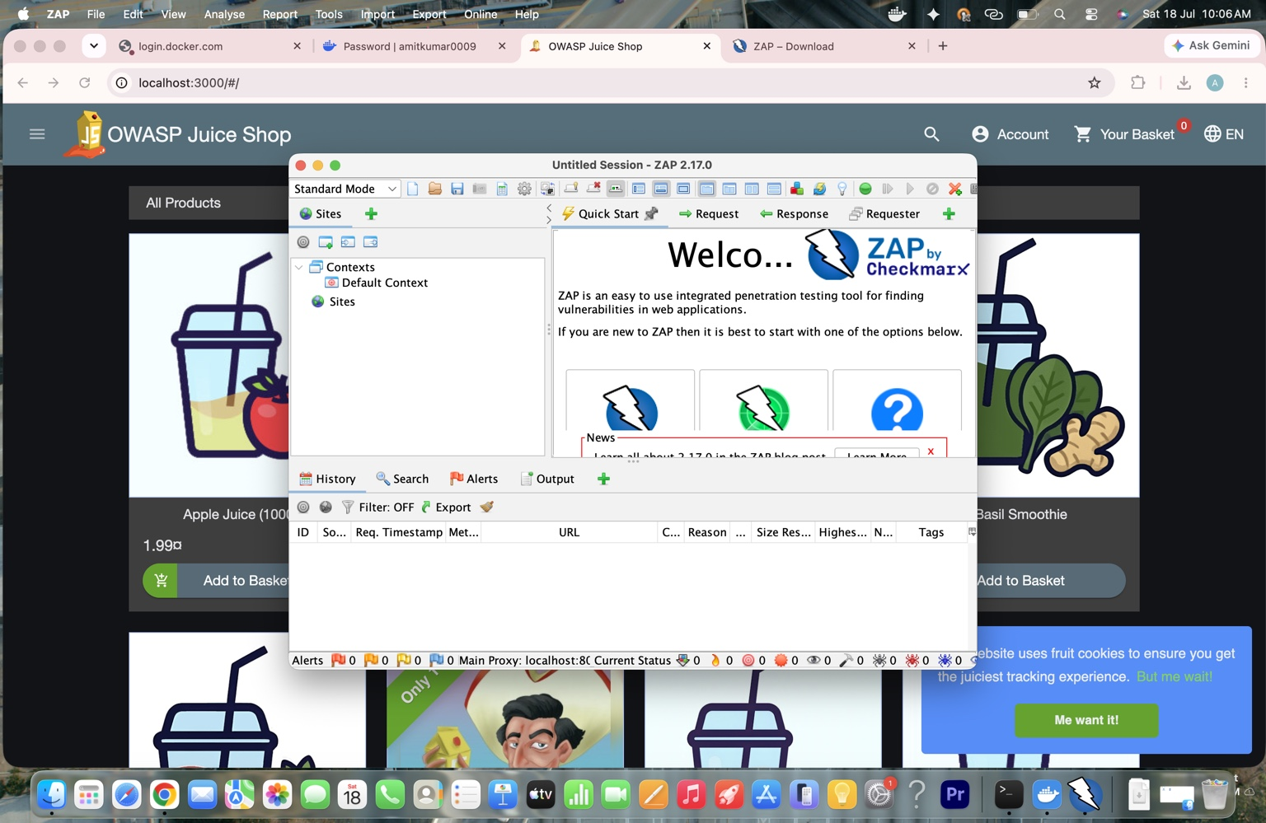
Summary
The OWASP ZAP tool started without issues. The Quick Start interface provides options for automated scanning and manual security testing.
Result: The screenshot verifies that this phase was completed successfully and the expected output was achieved.

6. Target URL Configuration
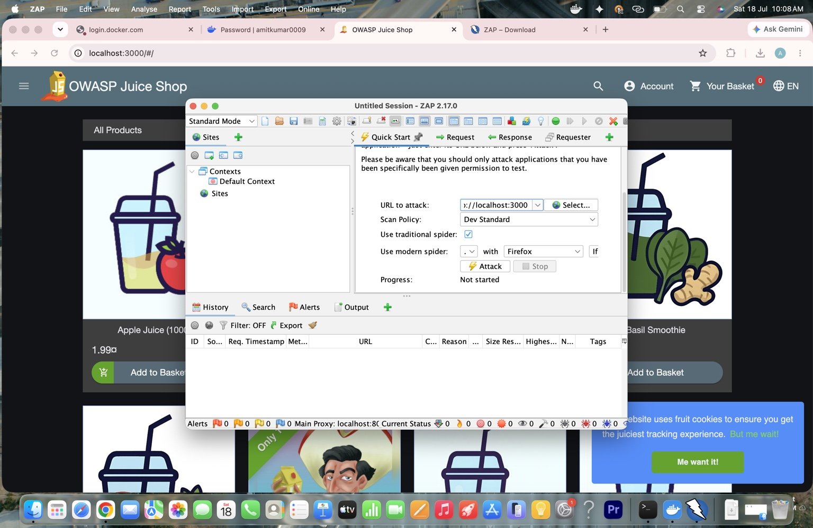
Summary
The application URL (http://localhost:3000) was entered into the Quick Start panel. The default scan policy was selected before initiating the scan.
Result: The screenshot verifies that this phase was completed successfully and the expected output was achieved.

7. Active Scan
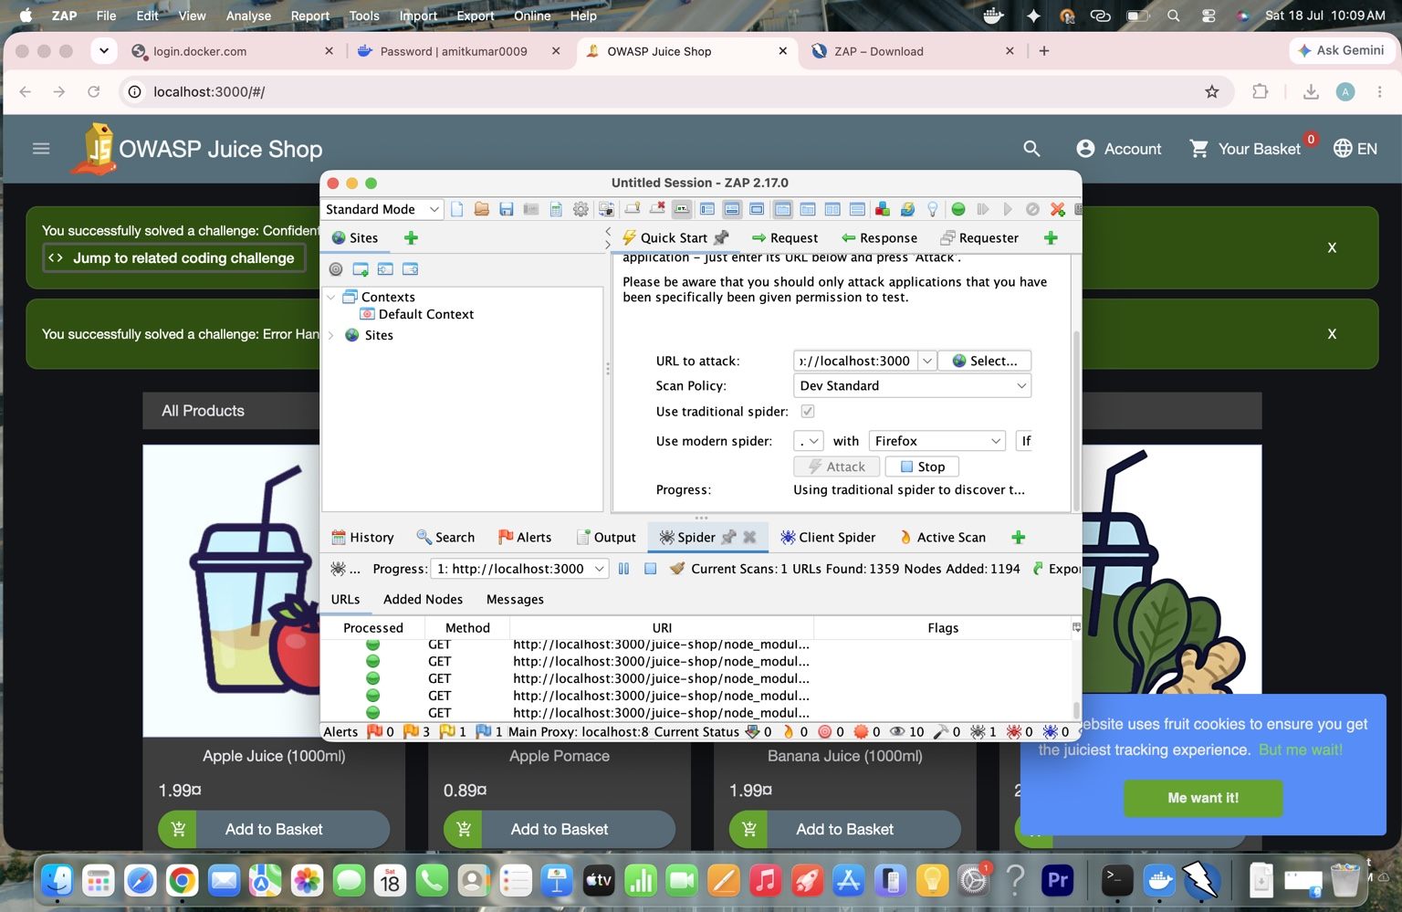
Summary
The active scan explored the application using the spider and tested discovered resources for common vulnerabilities. Multiple URLs were analyzed automatically.
Result: The screenshot verifies that this phase was completed successfully and the expected output was achieved.

8. Sites Tree
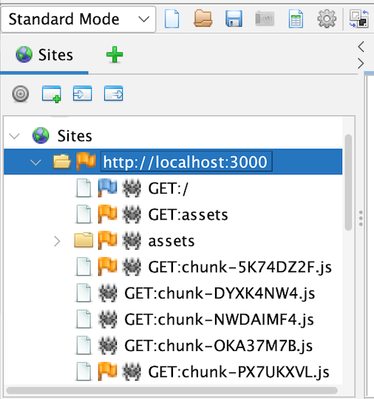
Summary
The Sites Tree lists all discovered application resources such as pages, JavaScript files and directories. It provides a complete view of the application's structure.
Result: The screenshot verifies that this phase was completed successfully and the expected output was achieved.

9. Alerts Panel
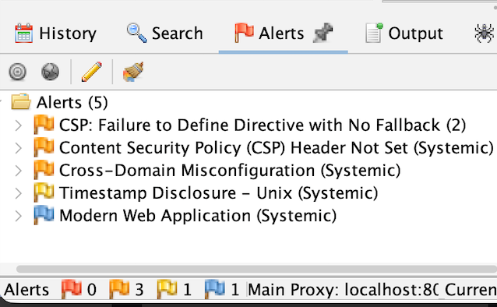
Summary
The Alerts panel displayed the vulnerabilities identified during the assessment. Alerts are categorized according to severity and type.
Result: The screenshot verifies that this phase was completed successfully and the expected output was achieved.

10. Content Security Policy (CSP) Header Not Set
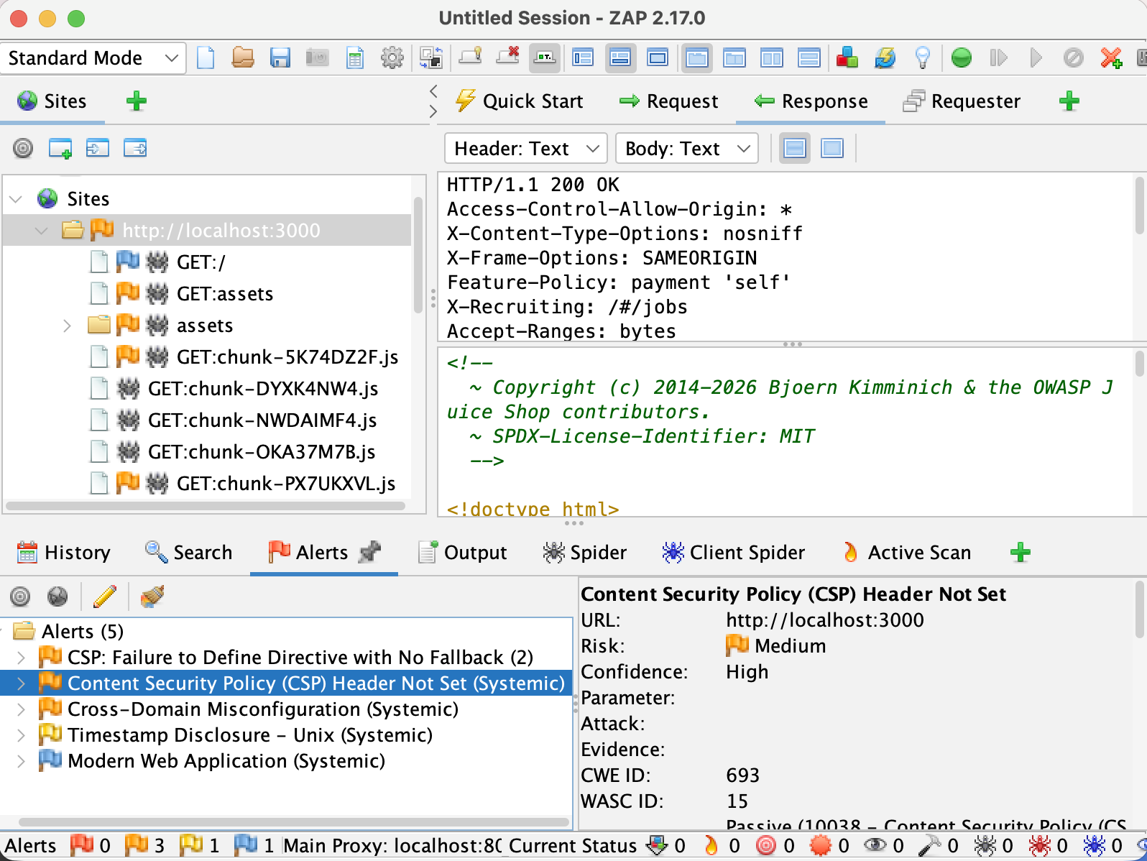
Summary
The scan identified that the Content Security Policy (CSP) header was missing. Without a proper CSP, browsers cannot effectively restrict malicious scripts, increasing the risk of Cross-Site Scripting (XSS) attacks.
Result: The screenshot verifies that this phase was completed successfully and the expected output was achieved.

11. CSP Failure to Define Directive
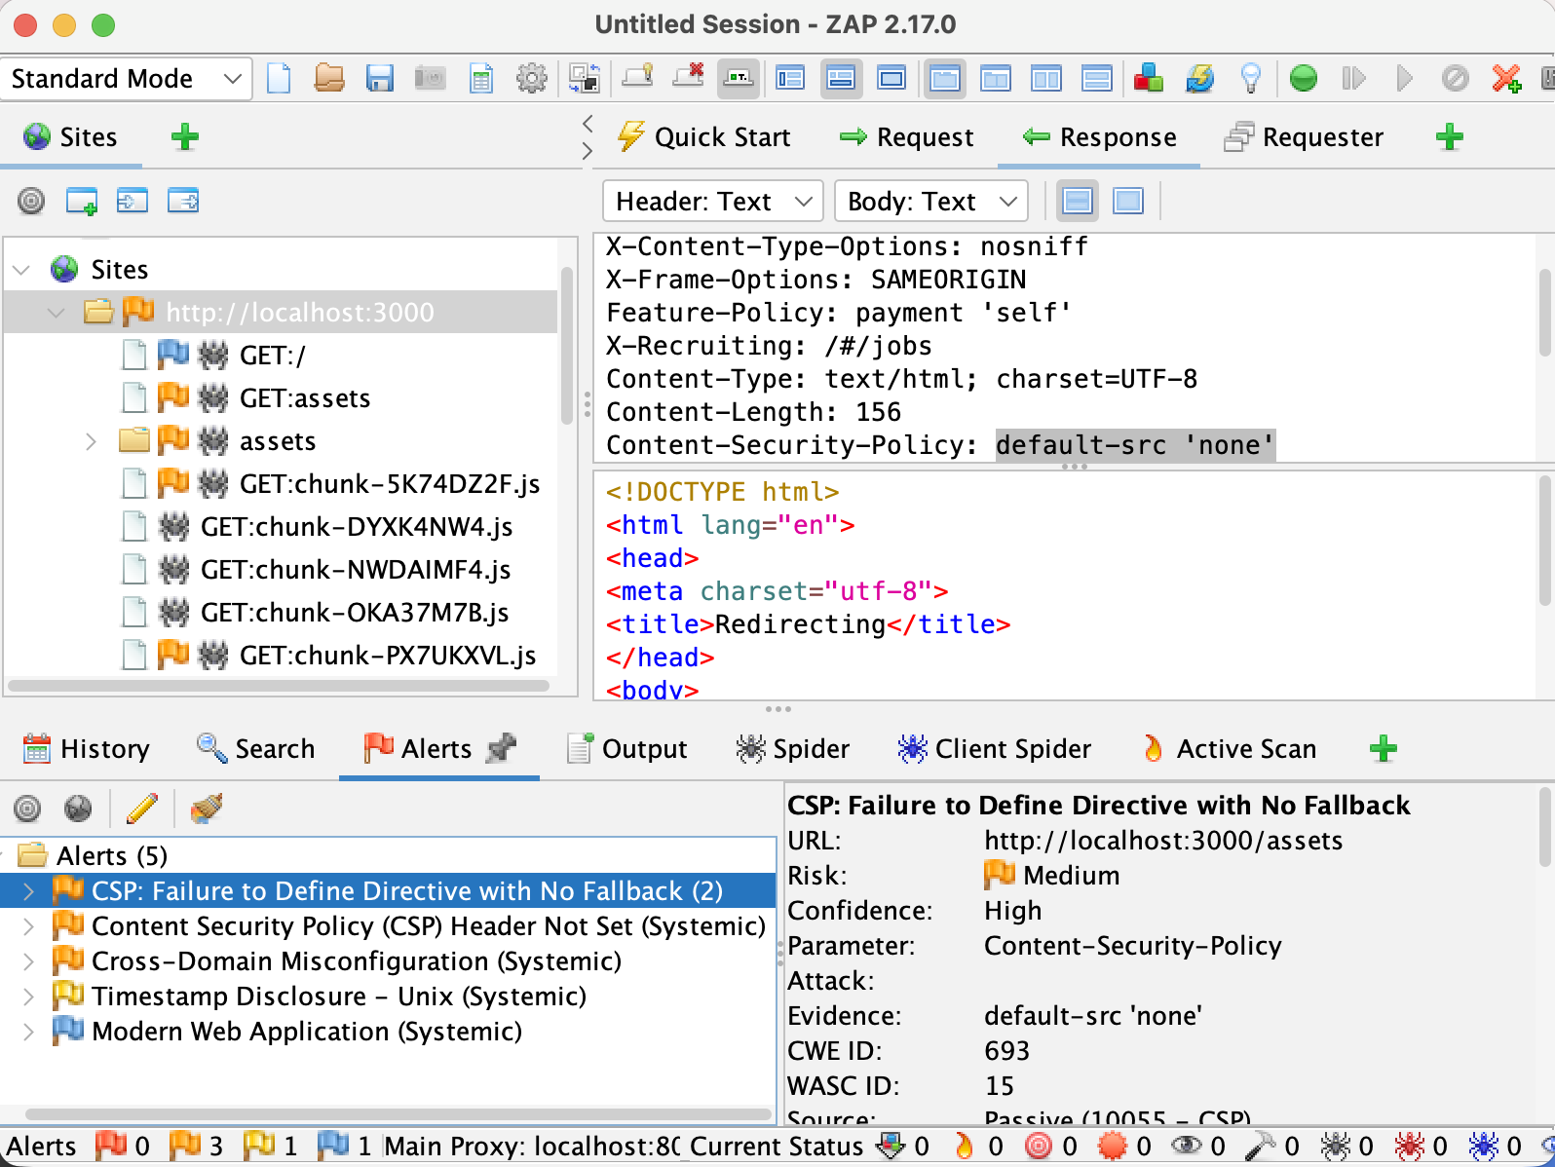
Summary
The configured Content Security Policy was incomplete because fallback directives were not properly defined. A stronger policy should be implemented to improve browser-side protection.
Result: The screenshot verifies that this phase was completed successfully and the expected output was achieved.

12. Cross-Domain Misconfiguration
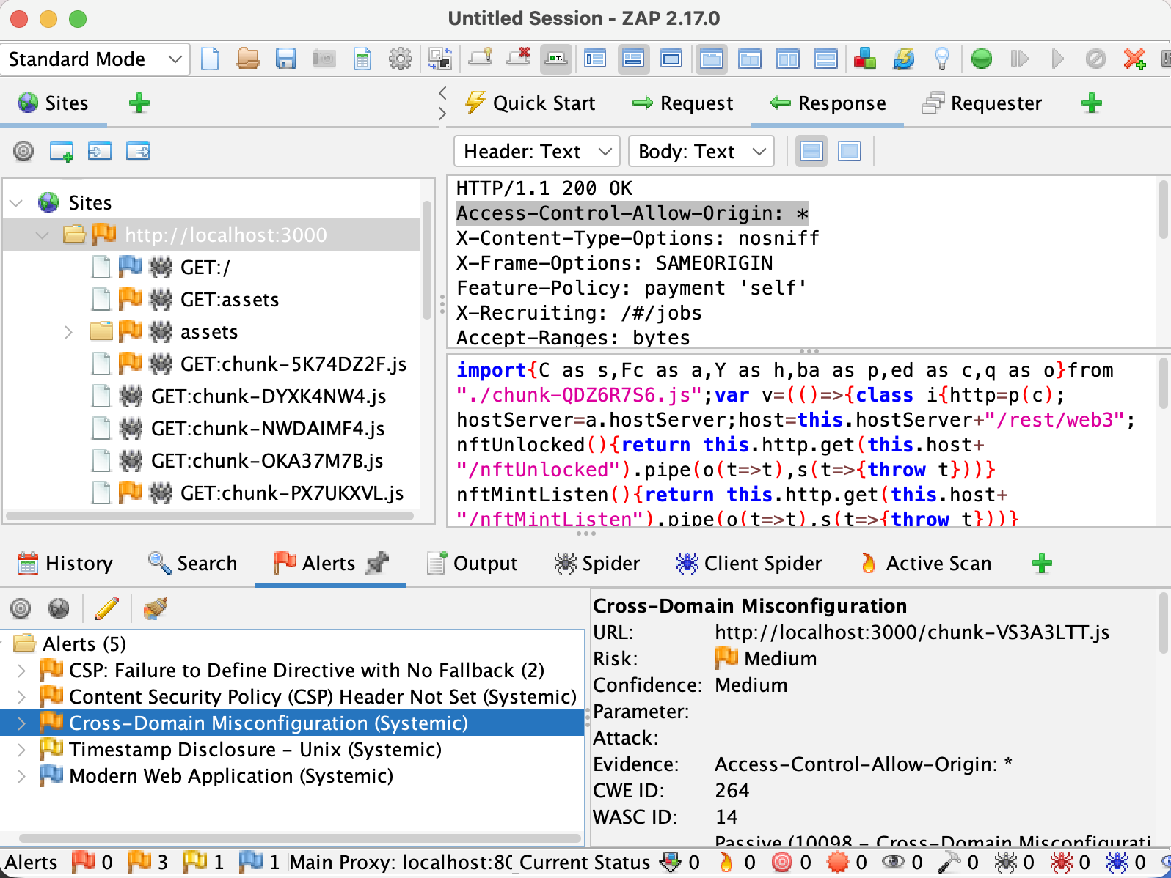
Summary
The application exposed a permissive Access-Control-Allow-Origin configuration. Improper CORS settings may expose sensitive resources to unauthorized external websites.
Result: The screenshot verifies that this phase was completed successfully and the expected output was achieved.

13. Overall Findings
• Content Security Policy (CSP) Header Not Set (Medium Risk)
• CSP Failure to Define Directive (Medium Risk)
• Cross-Domain Misconfiguration (Medium Risk)
• Timestamp Disclosure
• Modern Web Application Information

14. Recommendations
1. Configure a strong Content Security Policy (CSP).
2. Restrict Cross-Origin Resource Sharing (CORS).
3. Keep application dependencies updated.
4. Perform periodic OWASP ZAP security scans.
5. Implement secure coding practices and regular patch management.

15. Conclusion
The security assessment was completed using OWASP ZAP on the OWASP Juice Shop application. The project demonstrated the complete workflow of deploying a vulnerable application, performing automated security testing, identifying vulnerabilities and documenting security findings. The identified issues highlight the importance of secure HTTP headers, correct CORS configuration and regular security assessments.

